DHIS2 EXCEL REPORTTING TOOL
-
USER DOCUMENTATION

Table of contents
Contents
1 – Introduction 3
2 – Advantages of Excel report module 3
3 – Requirement of Excel report module 3
4 – Main features in Excel Report module 3
5 – How to use Excel Reporting Module 4
5.1 Create Excel Report template file and configure the path to folder where contains Excel report template file 6
5.1.1 Types of report 6
5.1.1.2 Reports list the organization units in the rows 6
5.1.1.3 Reports list time periods in the columns 7
5.1.1.4 Reports with data values are the combination between data elements and categories 7
5.1.2 Directory Configuration 8
5.2 Create a new report in DHIS2 with Excel report template file 9
5.2.1 Create new report 9
5.2.2 Create report items 11
5.3 Assign report 13
5.3.1 Assign report to Org Units 13
5.3.2 Assign report to user role 15
5.4 Generate report 16
5.4.1 Generate report 16
5.4.2 Generate advanced report 17
5.4.3 Generate an individual report 17
5.4.4 View data set complete reports 18
5.4.5 View data entry status 19
5.5 Import data values from Excel file to DHIS 20

DHIS2 EXCEL REPORTTING TOOL
-
DOCUMENTATION FOR USER

1 – Introduction
- The fact that almost health workers are familiar with office softwares, such as: Microsoft Office, Open Office, etc. to make reports is demanding. For the health workers, the statistical reports are very important to submit to the managers with Excel format file which is easy to modify, customize and transmit.
- Users, esp. the health workers, can use DHIS 2 easily with the new Excel reporting tool developed by HISP Vietnam team, based on HISP India team’s ideas and technologies HISP India and Vietnam team and embedded into DHIS 2 for local users in Vietnam. This reporting tool with Excel output files uses less memory and is comparatively faster when compared to other reporting module.

2 – Advantages of Excel report module
- User-friendly
- Open and Easy to be customized for reports
- Fast to edit, modify and generate report

- Do not require large memory but allow large number of users generating report at same time without out of memory exception.

3 – Requirement of Excel report module
- User’s computer has to be installed Microsoft Office or Open office. However, this may be solved by Preview function to view report via web.

4 – Main features in Excel Report module
Create report
Generate report
Import data from Excel file into Database of DHIS

- Create report
  - To create many types of report, such as: report containing standard data elements, report listing organization unit groups as rows, report listing period of time as columns, report generating data elements combined with categories.
  - The report item types for designing reports, such as: data element, indicator, serial no (for generating sequence no in report), data element name, data element code, organization unit name, and organization unit group.
- Generate report
  - Allow users to generate reports according to parameters: period of time, organization unit, organization unit group and to generate group of reports to many sheets of 1 Excel file.
- Import data from Excel file into Database of DHIS
  - In the need of saving and transmitting data between health workers or within the local organization units where internet is not available. User may need to enter data in excel file and import it into the database. This feature allows user to import data from a pre-designed excel template into DHIS database automatically or just import some data elements specified by users.

5 – How to use Excel Reporting Module
To start using Excel Report Module, from the Main menu, chose Services, then click Excel Reports. See below:
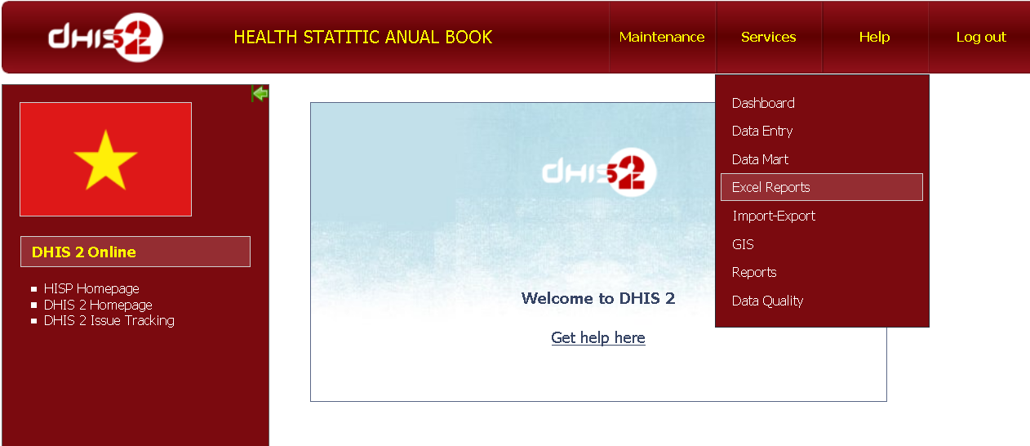
Services modules
Main menu
Excel Reports module
Then a new page appears as following:
Left menu
Administration function
Generate Report function
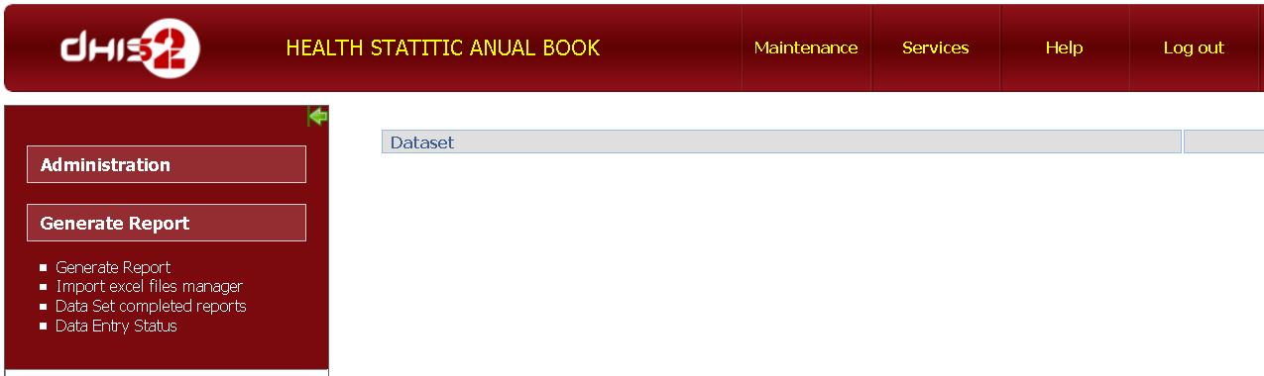
At the Left menu, there are 2 main functions: Administration and Generate Report
- Administration function includes:
  - Configurations: Set a path to the directory where the excel template files are stored.
  - List of reports: Allows users to create reports and its items and to assign the organization units or the organization unit groups to the reports.
  - Data Entry Status (or view the status of the data entry): View the data entry status to know about data entered, report finished or not finished yet with data entry. In order to view the data entry status, adding data sets which is equivalent to the data entry is mandatory.
  - Clean temporary directory: Every time a user generates a report, the system creates an excel file in the temporary directory (excelreporttemplate directory). This directory would be larger and larger after some time and occupy a lot of memory. This function will clean those files from temporary directory.
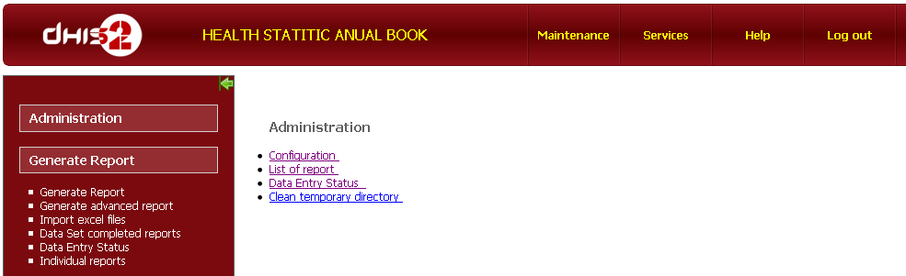
- Generate Report function has sub functions:
  - Generate Report: generates reports
  - Generate advanced report: Generates reports by Org Unit group.
  - Import excel files: imports data values from an Excel file to the DHIS’s database
  - Data Set completed reports: generates the report status of completeness of entering data .
  - Data entry Status: views data entry status.
  - Individual reports: generates user’s defined reports
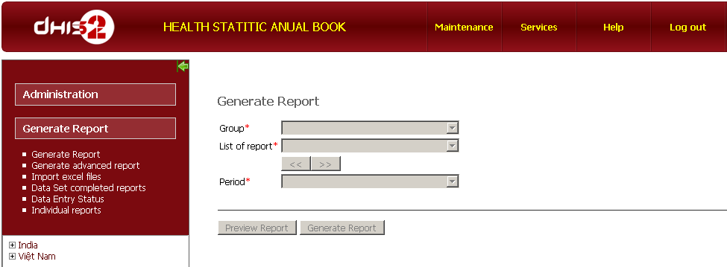

User can generate reports using Excel Reporting module steps by steps as below:
Create Excel report template file and configure the path to folder where contains Excel report template file.
Create new report in DHIS2 according to Excel report template file
Assign report to Org Units, Org unit groups and User Role
Generate report

  - Create Excel Report template file and configure the path to folder where contains Excel report template file

Types of report
Before generating reports we need to have Excel template files and the reports will be generated in the standard forms following the templates. Currently, there are 4 report types that the module can support.

Standard reports contain default data elements and indicators
Standard reports have fix model in which number of the columns and the rows are unchangeable. And normally, this report is generated by only 1 organization unit or 1 organization unit group at a specified period of time.
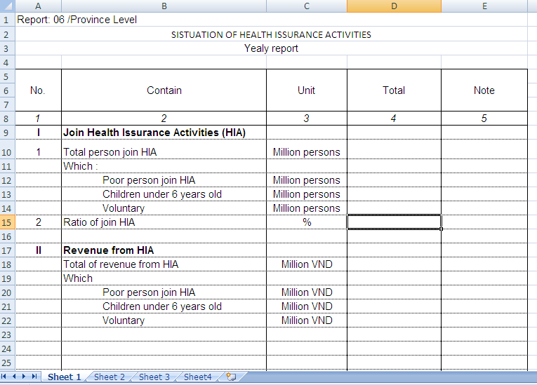
Data elements’ name
Data elements’ name
Data elements’ name
Indicator
Data element’ value displayed in this cell
Indicators’ values displayed in this cell
Data values

Reports list the organization units in the rows
This type of report displays data elements’ name in the fixed columns, and organization units are be displayed automatically according to the selected parents organization unit in a period of time. These organization units are also grouped together following the administrative level, such as: province, district, commune, etc.
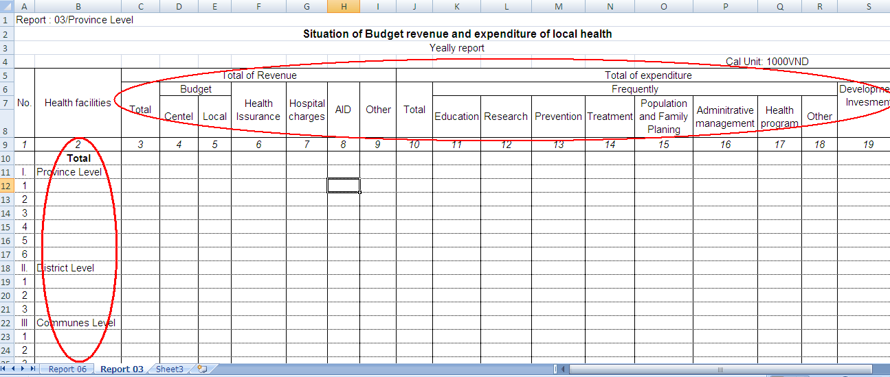
Org Unit Group name
Org Unit name
Data element name
Data element name
These Org Units would be displayed automatically according to selected parents Org Unit
Data values would be displayed in these cells

Reports list time periods in the columns
This report display data values according to the fixed data element names, and the list of time periods are displayed automatically.
Time period
List of Time periods
List of Data element name
Selected Org Unit
Selected Period
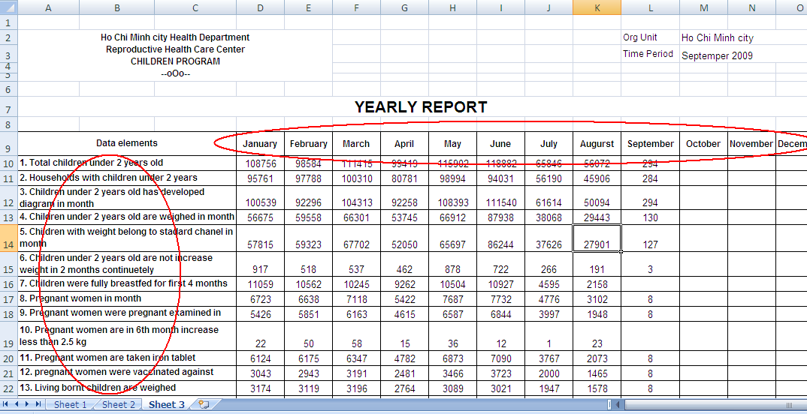

Reports with data values are the combination between data elements and categories
This type of report displays data values which are combined of data elements and category combination. Data element names display as rows and category options are displayed as columns. Data elements’ names, codes may be displayed automatically as well as the sequence numbers of the rows.
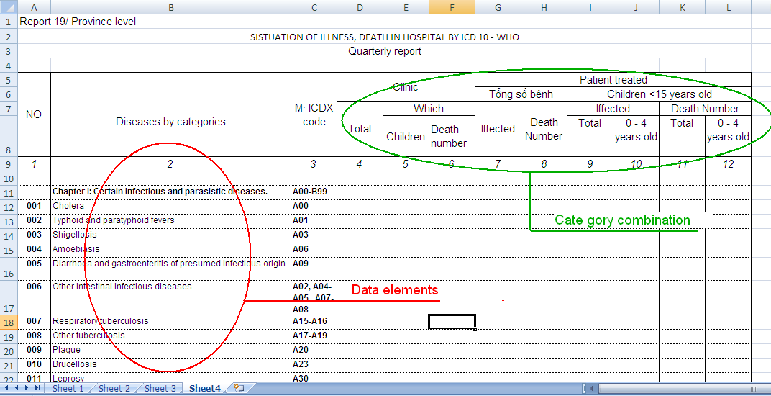
Sequence no
Data element names
Data element’s code
Category option
Save the template file in a specified folder where DHIS is installed.

Directory Configuration
Directory Configuration is to set the path of the directory containing the ExcelTemplate (.xls) file.
Administrator > Configuration> Set path to folder contains excel file
- Click Administration to open Administrator page.

- 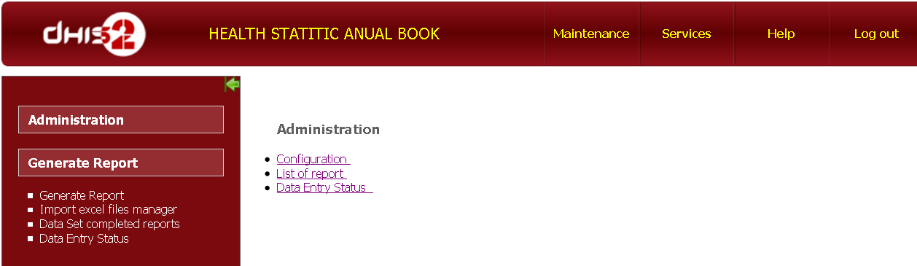
2. Click configuration
1.Click Administration
- Click Configuration button
- Set a path to the folder containing excel file
Excel template directory is a directory created in the system, recommended inside the folder of DHIS 2.
Click Ok to save
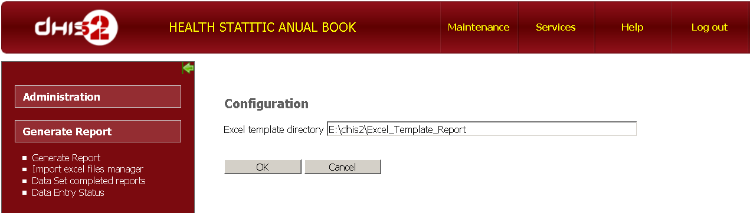
Path of Excel template file
Click to save

Click Ok to save

Create a new report in DHIS2 with Excel report template file
When the Excel report template file is available, creating a new report and the relevant report items are required. See below:
- Create new report : Administration --> List Of Report --> Add --> Fill the information form --> Ok
- Create report items in the report : Administration --> List Of Report --> Report Items --> Add --> Fill information form -->Ok

Create new report
Click List Of Reports
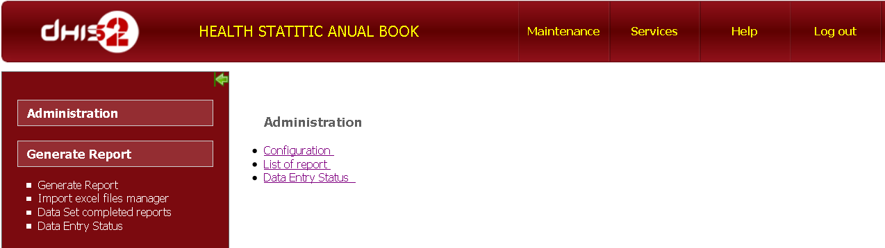
1.Click Administration
2.Click List of report
- Add new report: Click Add button to add new report
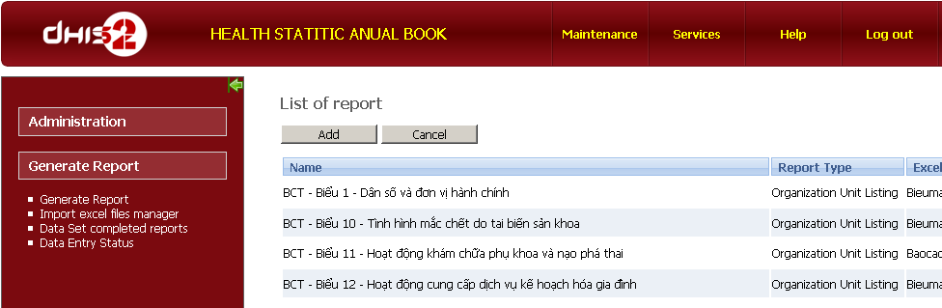
Click Add button to create new report

Fill the information in this form:
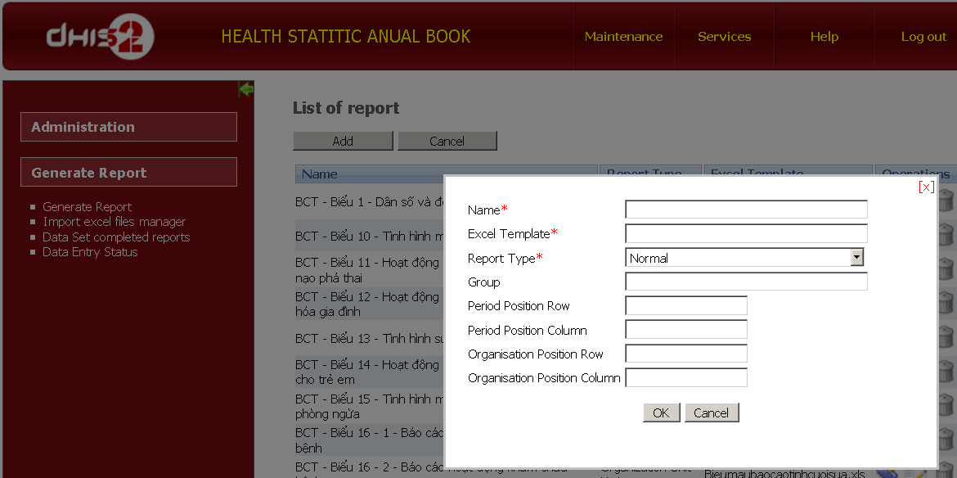
Enter Report’s name
Enter ExcelTemplateName.xls
Select Report Type
Enter new group name or choose existing group
Enter Period Position Row
Enter Org Unit Position Row
Enter Org Unit Position Column
Enter Period Position Column
Click Ok to create new report

- Name *: Enter Name of report
- Excel Template*: Enter name of Excel report template file. (include extension)
- Report Type *: Choose report type
  - Normal : to create reports include just data elements or indicator
  - Category : to create reports with data values are combined of data elements and categories
  - Period column listing: to create reports which list data values according to time period of specified organization unit.
  - Organization unit listing: reports which list data values according to organization units.

- Period position row and Period position column: Row and Column Number in Excel template file where to put Period value.
- Organization Unit Row and Organization Unit Column: Row and Column Number in Excel template file where to put Organization Unit Name.
- Click Ok button to create new report
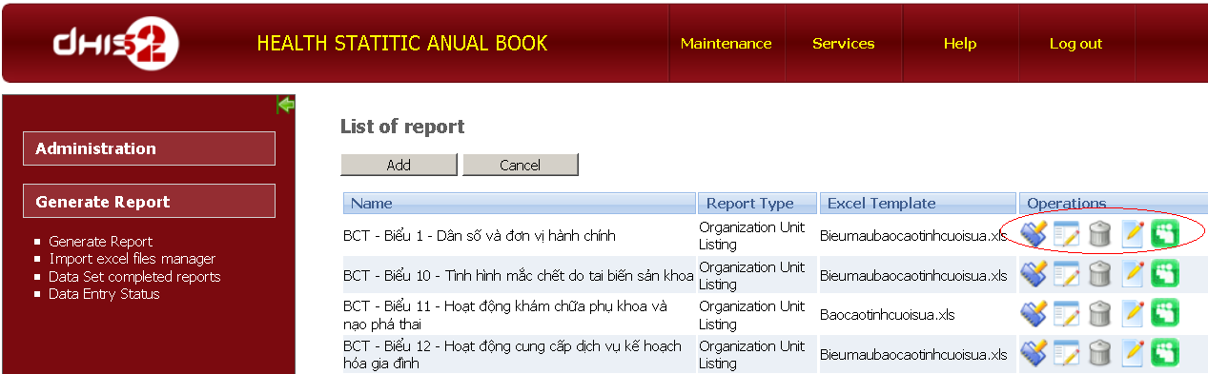
Report’s name
Report Type
Excel template file name
Operating buttons

The Operating buttons:
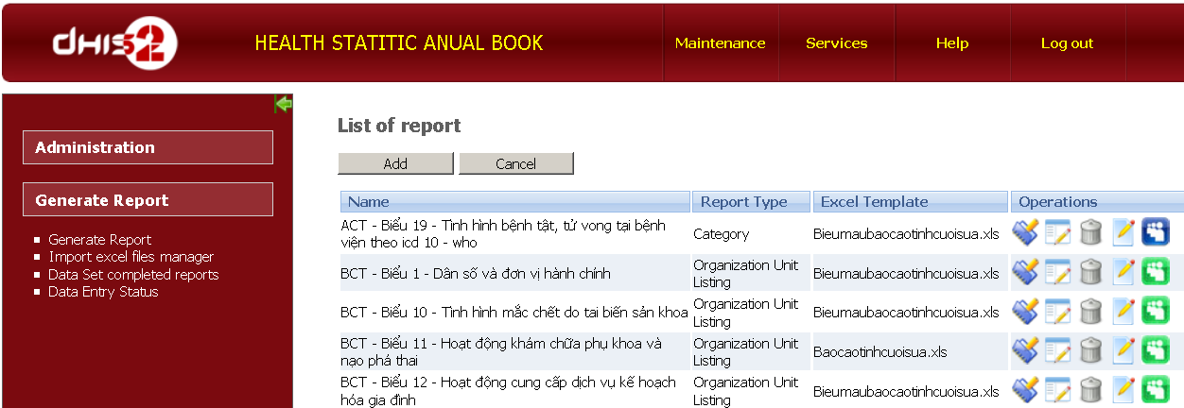
Select Org Unit group
Edit Report
Delete Report
Create Report Item
Select Data element group
Assign Org Unit
There are 4 buttons to work on each report:
- Report Associations For assigning reports to organization units
- Report Item For creating report items in the report
- Remove For removing report
- Edit for editing report’s information.
- Organization unit Group : For choose which organization group would be list in the report. This button only appear when the Report Type is Organization Unit Listing
- Data element groups: This button only available when report type is Category. This button for create Data element group and these groups of data elements would be list in the report.

Create report items
Click Report Item button:

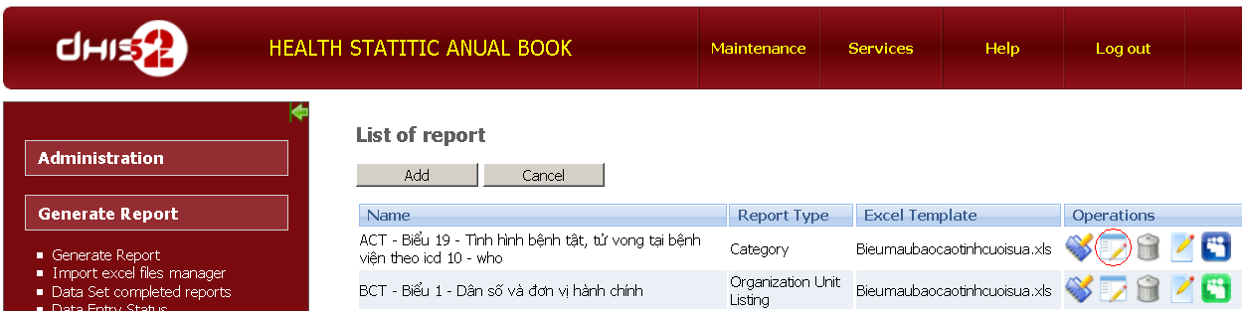
Create Report Item
- Add button : add new report items

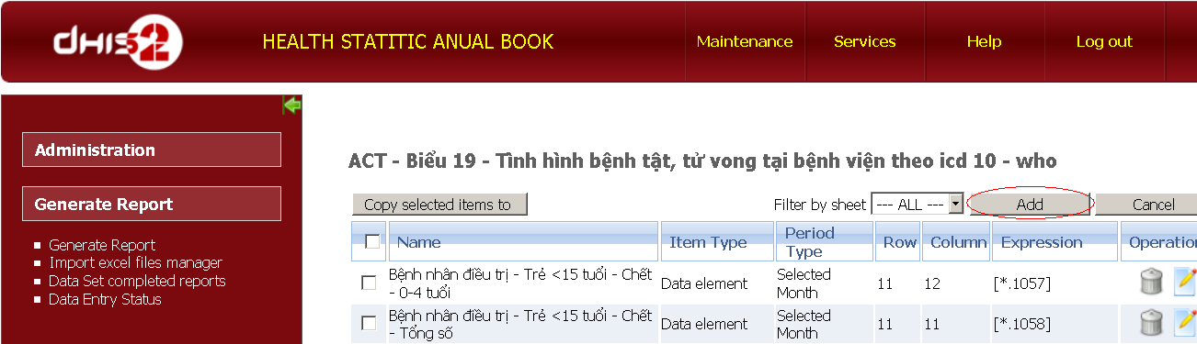
Add new Item
Delete Selected Item
Copy selected Item to another report
Filter Item by sheet
- Fill the report item’s information
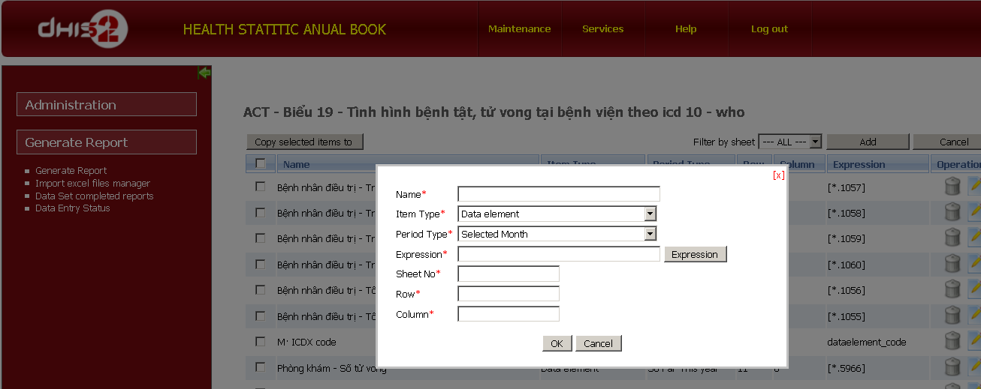
Enter Report item name
Select Item type
Select Period type
Set Expression
Enter sheet no
Enter cell’s row
Enter cell’s column
Click OK to create Item
    - Name*: Enter report item name (Ex: Total person joined HIA)
    - Item Type*: Chose item types
      - Data element : if this report item is data element
      - Indicator: : if this report item is indicator
      - Excel formulary: if this item describes the excel formulary
      - Data element Name: if report item is list of data element’s names
      - Data element Code: If report item is list of data element’s codes
      - Serial : If report item is list of auto generating sequence no
      - Organization: if report item is list of organization unit.
    - Period Type*: Chose period type which data values of that report item would be aggregated and displays according to period parameter that user will choose when generate report. (Last 3 months, Last 6 months, So far this year, Quarterly, Six-Monthly, Yearly).
 | There is at least 1 period type in a report.
    - Expression *: Click Expression button to choose Data element, Indicator, Or just type excel formulary if Item type is Excel formulary.
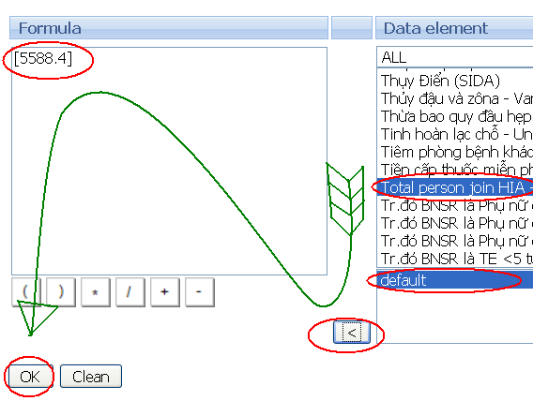
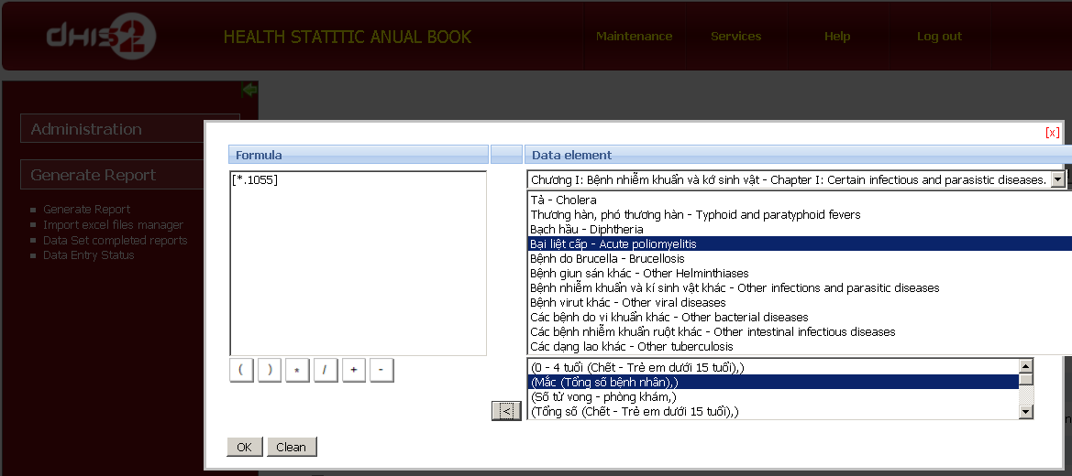
Select Data element group
Select Data Element
Select category option
Click to get formula
Click to set expression
Click to delete formula
Expression
Operator Buttons
The category option would be default if data element hasn’t been combined with any category combo
    - Sheet No*: type sheet no where this report item would be display in excel template file
    - Row*: row number refers to cell where report item would be display in Excel file.
    - Column*: column number refers to cell where report item would be display in Excel file.
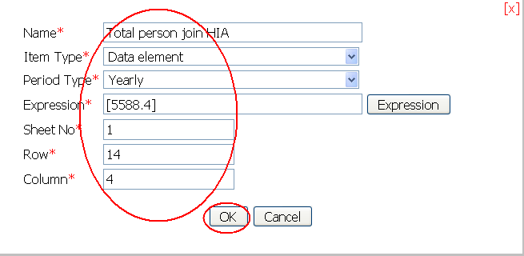
    - Click Ok button to create report item.
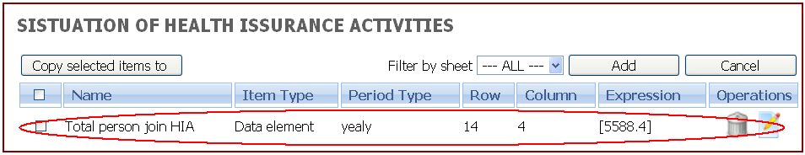
  - Copy selected items to button: Tocopy the report items when the new report has an item which can be reused from the existing report. 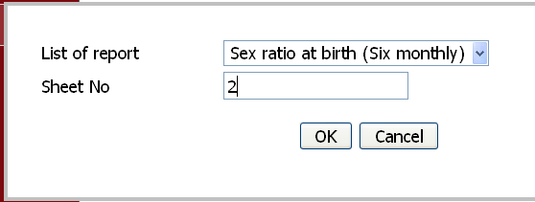
Tips | - Copy selected items to other report for fast developing many reports with the same data elements but with the difference from period aggregated data values.
List of report: chose a destination report
Sheet No: Choose the Sheet No which report Item would be display.

Assign report

Assign report to Org Units
Click Report Associations button:
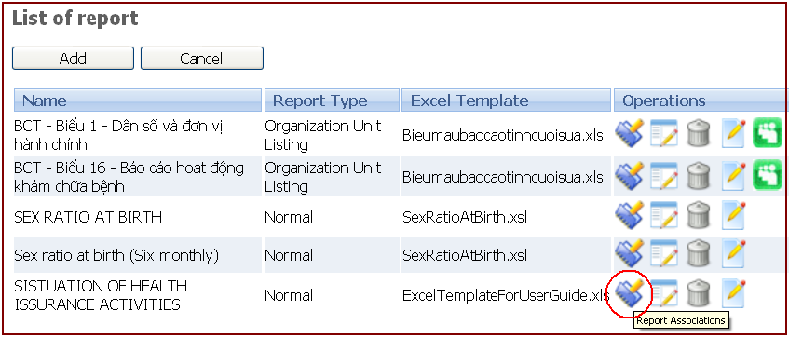
Chose Org Units to assign and click Save button:
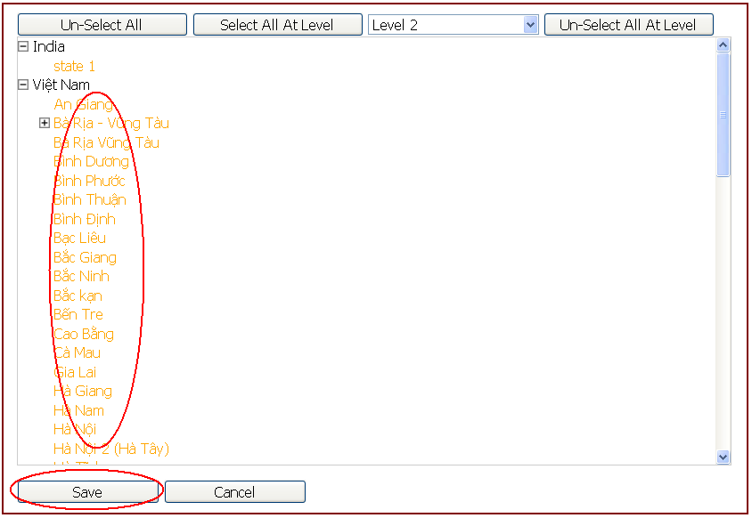
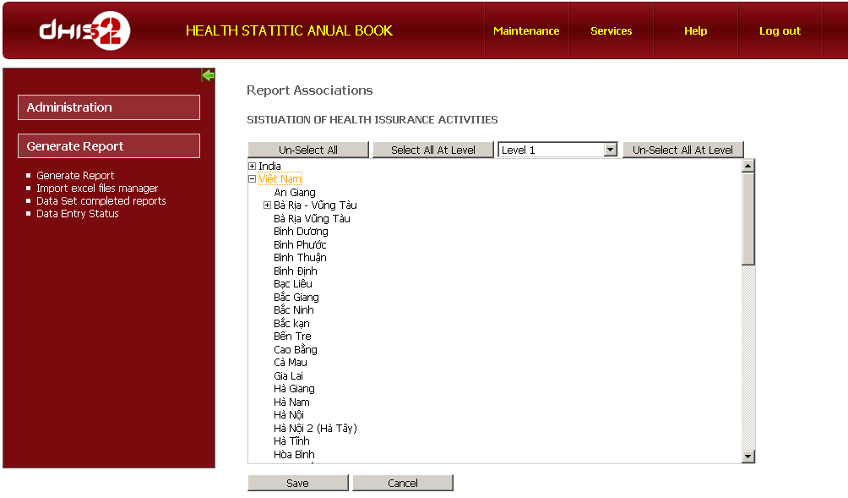
Choose level
Chosen Org Unit
Click to save
Unselect all org Unit
Select all Org units at chosen level
Select all Org units at chosen level

Select Org Unit groups which would be available in report
This function only appears in Organization Unit Listing report type. Click Organization Unit group button
Click to Select Org Unit groups

Select Organisation unit groups, arrange sequence of these groups and click Ok to save
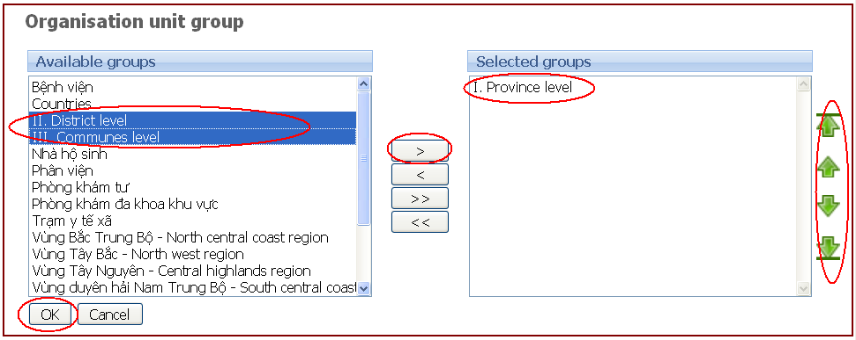
Available Org Unit Group
Select/Deselect buttons
Change sequence buttons
Click to assign

Assign report to user role
To manage the authority of using the reports, we should assign reports to user roles.
- From Main menu, choose Maintenance > Users
- From Left menu, chose User Role
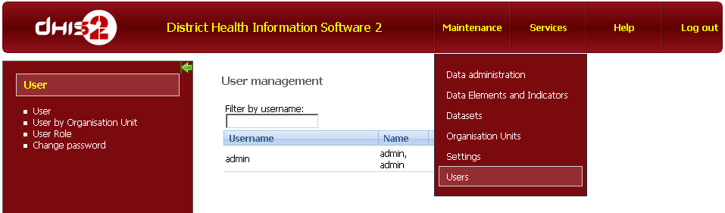
1.Click Maintenance
2.Select Users
3.Click User Role
- Click Edit button to edit User role’s information
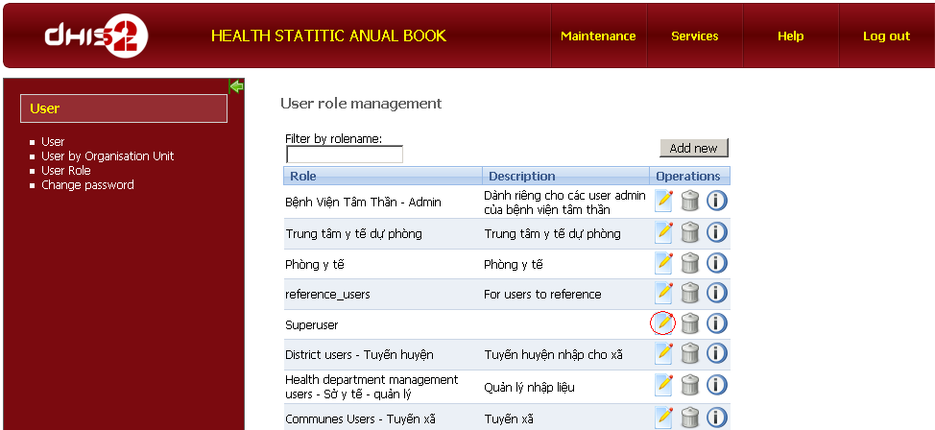
Edit User’s role

After selecting Excel reports, click save button to assign excel reports to user role.

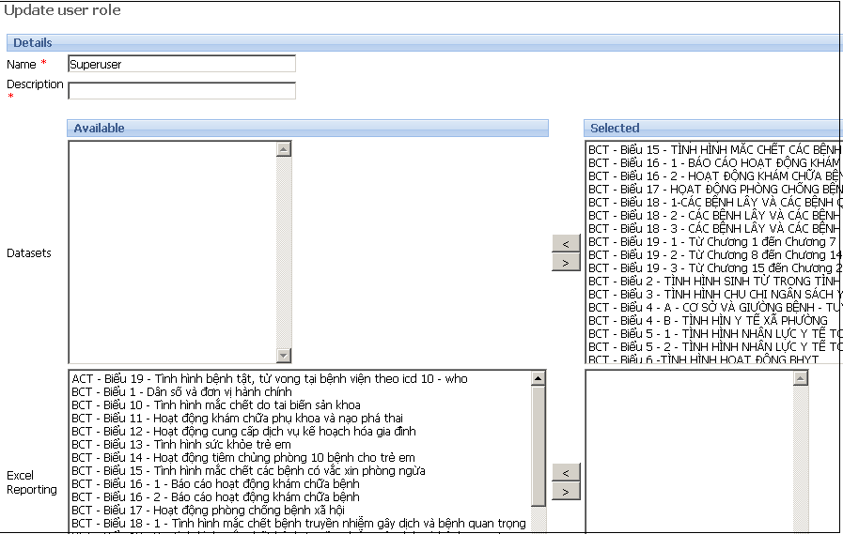
Excel Reports
Select/Deselect button

Generate report

5.4.1 Generate report
To generate a report we can follow these steps:
- Click Generate Report >
- Select Org Unit>
- Select report Group >
- Select Report from list>
- Select period>
- Click Generate Report button.

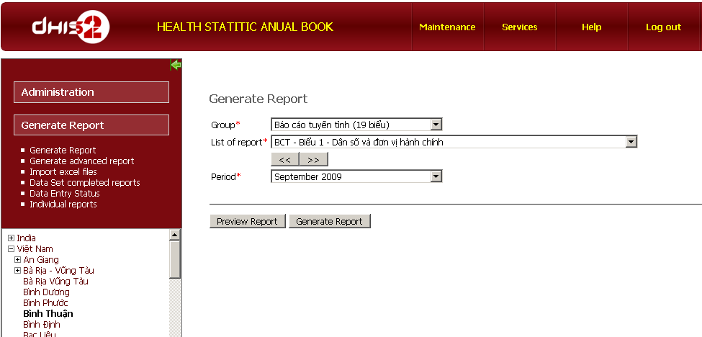
1.Click Generate Report
2.Select Org Unit
3.Select report group
4.Select report
5.Select period
6.Generate report in Excel
Generate report in web

The Preview Report button is used to preview report via web when Excel hasn’t been installed in the system.

5.4.2 Generate advanced report
This Generate Advanced Report function allow users to generate a report according to the parameters such as: Report group name, Report name, selected period, and organization unit group name. The difference between Generate Advanced Report function and Generate Report function is that the advanced one can generate report according to group of Org Units with the same level, for example
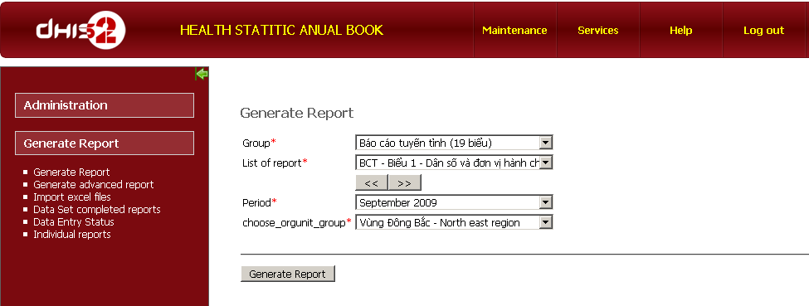
1.Click Generate advanced report
2.Select Report Group
3.Select Report
4.Select period
5.Select Org Unit Group
6.Click to generate report

5.4.3 Generate an individual report
This function allows users to generate the reports with data elements and a list of period as their individual decision. Another way, user can generate a dirty report by selecting data elements, periods to generate a simple excel report without excel template file or creating report or report items. Then, user can bookmark this report for generating later. The steps to generate individual report:
- Click Individual report function from the left menu
- Select organization unit
- Select data elements
- Select category option of selected data element
- Click select button
- Select period type
- Select periods
- Click select button
- Click generate report button
- Click Book mark button for generate later
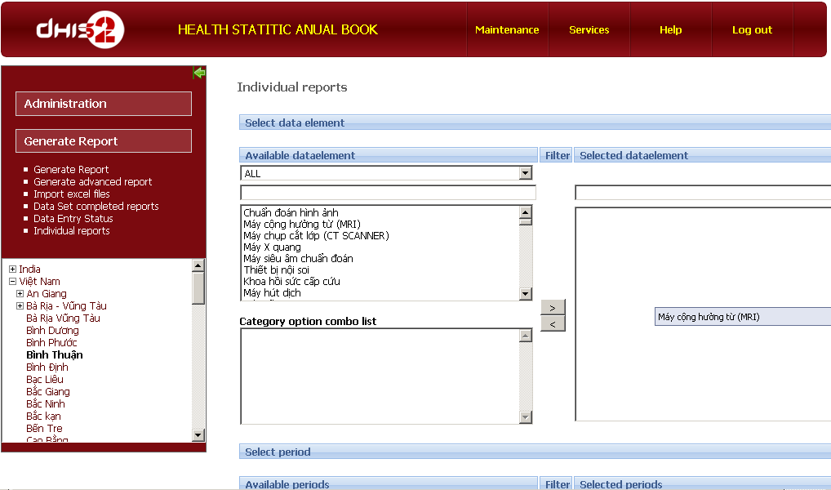
1.Click Individual reports
3.Select data elements
4.Select category options of data element
5.Click Select/Deselect button
2.Select Org Unit
6.Select period type
7.Select period
8.Click select/deselect button
10. Click Book mark to save report
9. Click to Generate report
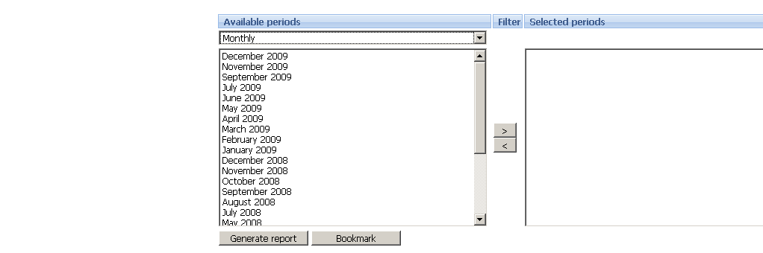

5.4.4 View data set complete reports
When users finish entering data for a data set, they need to click COMPLETE button to identify that the data set is completely entered. View Data set complete report function takes care of this completeness.
There are 2 ways of viewing data set complete reports. View as Period or Dataset. When viewing with Period, user can see the datasets according to many periods of time. Viewing with Data set, users can see many data sets in only a specified period.
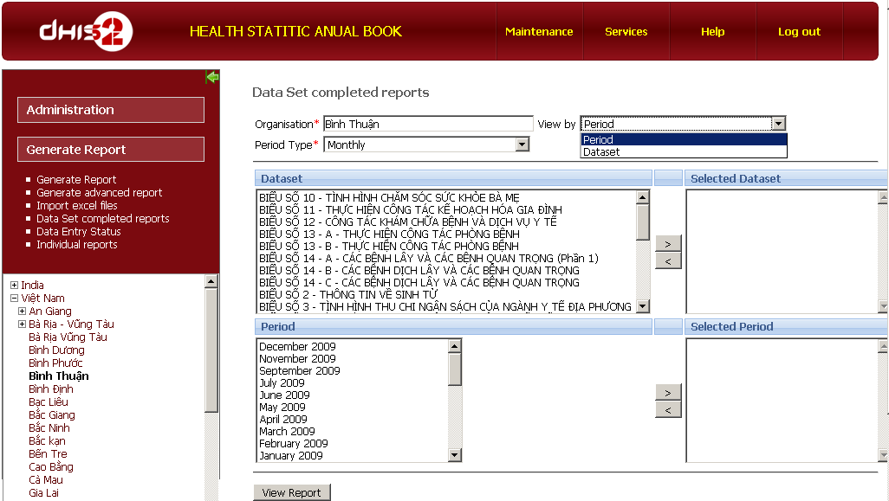
1.Click Data set completed reports
2.Select Org Unit
1.Select period type
1.Select Period/Data set view
Select data sets
Select period
Click to view

5.4.5 View data entry status
View data entry status function allows users to see which datasets are entered with data and how the data values are entered. This helps save time for the health manager to follow the completeness of the data entered. In particular, there is a need of viewing data set entry status.

- Add data set to view
1.Click Administration
1.Click data entry status
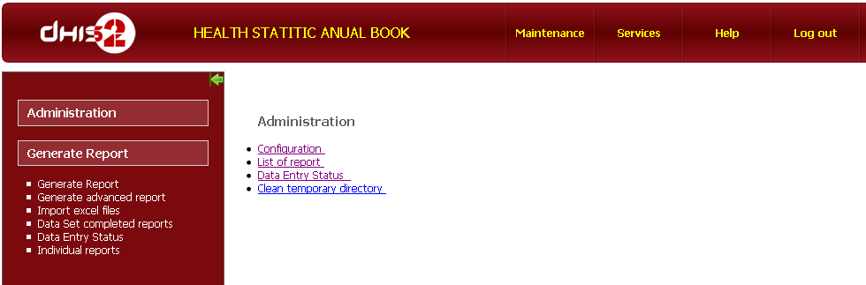
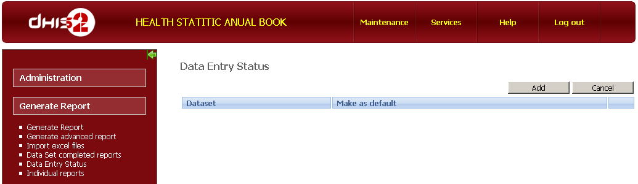
Click to add dataset
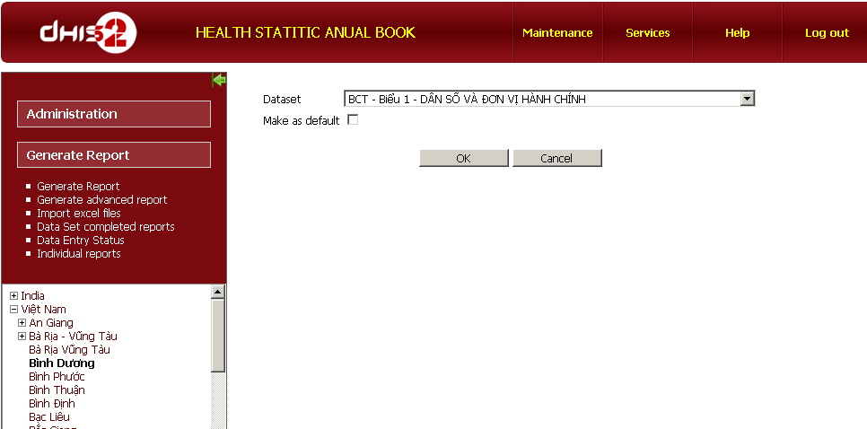
Select Org Unit
Select data set
Mark as default to view each time log in into DHIS
Click to add data set
- View Data entry status
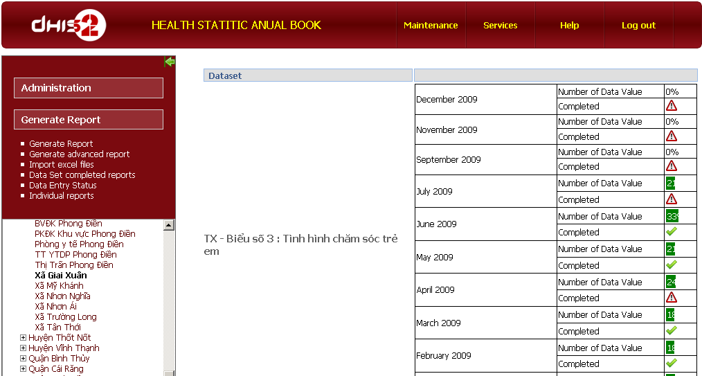
Click to view data entry status
Select org unit
Data set name
Data entry status
Completed
Uncompleted

Import data values from Excel file to DHIS
This feature allows users to import data from Excel file to DHIS’s database.
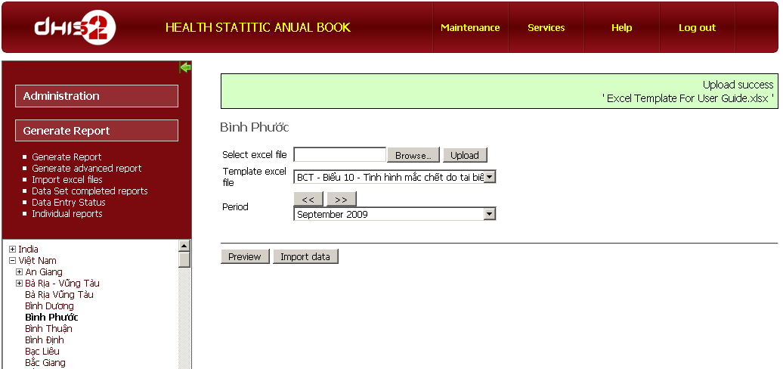
Select Org unit name
Browse and Upload Excel file with data values
Note filed upload completed
Select template Excel file
Select period
Preview data
Import data into data base

The steps to import data from Excel file to data base
- Select Org Unit name
- Select and upload excel file which contains data values
- Select template excel file.
- Select period
- Press Preview button, the system show data elements and correspondent data values, as follow picture
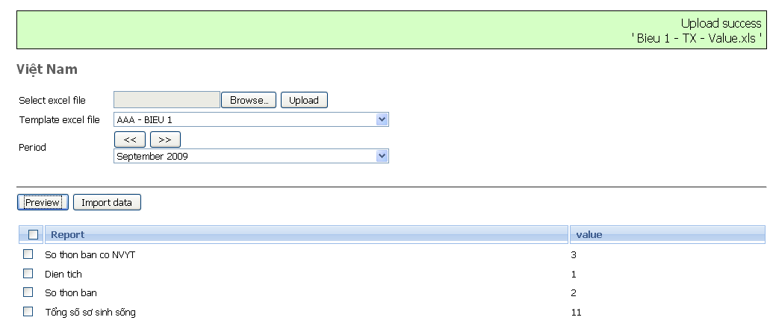
Data element
Correspondent data value
Check to select

- Check to select data elements to import.
- Press Import data button
Requirement for importing the data with Excel reporting module: Excel files which contain data values must have formatted in the same form with the items in the Predefined Excel template file.
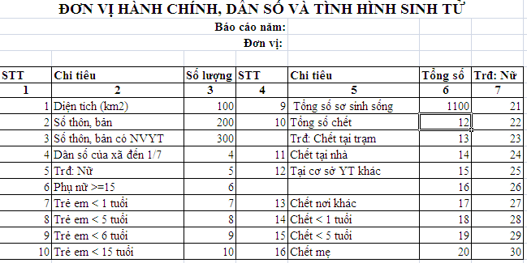
Example with an Excel file contains data values
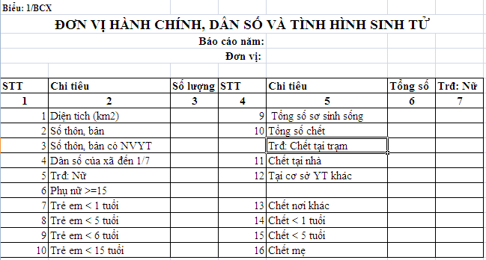
An Excel template file
 | Both Excel file with data values and Excel template file must be same at format.

The EXCEL reporting module is continuing develop and the documentation of it for users will be updated. All feedback will be appreciated, please inform us at dhis2-devs@lists.launchpad.

